**Virtual History**

Group 9: Denis Doçi, Alexander Anderson, Pawel Zimnoch, Katarzyna Krawczyk

**Brief Description:**

Virtual History is virtual reality based history education system that allows users to interact with different environments, events, and objects that carry historical significance. The system is a virtual classroom that allows users to step through preset eras of history, and gather a first-person perspective of those eras. Users will be able to interact with the environments they see, and learn facts about these environments as they experience them. Instructors will be able to select eras, choose between automated or manual narration, and quiz students on those lessons.

**Purpose:**

History education is mostly based around the fact that textbooks attempt to cover a lot of material in a small amount of space. This reading can be tedious, especially when done for the purpose of remembering pure facts compared with actually understanding the context of the time and event. A virtual reality environment allows for an immersive experience that allows students to learn in a much more effective way.

Full immersion in educational settings, especially for the subject of history, is a better tool than traditional methods. Technology is much more engaging than a traditional textbook. When a student simply reads from a textbook, they are not engaged in a meaningful way. With this product, we hope to further the development of education to be more conducive to the students wants, and make learning more immersive. In doing this, the product will serve to engage the user in a way textbooks simply can’t.

**Scope:**

The scope of the work on the project will be mostly defined by communication between student to teacher and teacher to our system. The teacher will dictate the usage of the product in real time, and will also send analytics of quizzes to our system to test the efficacy of the product. Students and teachers will be able to report bug, and benefit from the constant upgrades from our system. Demonstrated in these diagrams.

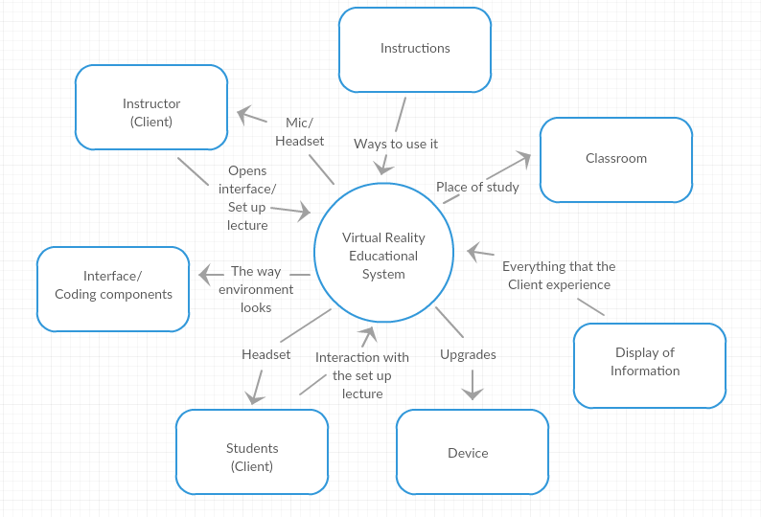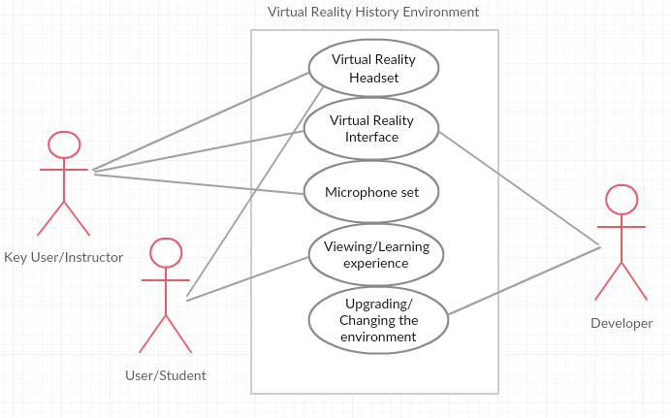

**Stakeholders:**

The main client for our product is educational institutions. The entire system will be too expensive for an individual consumer to *reasonably* afford, but institutions will have no problem with the pricing. The costumers are the instructors as they are the ones who will see the value in our product and help sell it. Users for this will obviously be students learning history, but also instructors running the lesson. Their participation in this will be set by the instructor. If the instructor wants more of a movie type experience, they can choose that. But more likely they will choose an interactive interface that allows students to engage with the simulations in the created environment.

Maintenance for our product will be dictated by both hardware and software. Virtual reality hardware is very sensitive. Based on the fact that users will physically handle the device, hardware maintenance packages will a necessity. Software maintenance will be handled through the internet as the hardware will have Wi-Fi capabilities.

**Constraints:**

Because the product will be used within classrooms, the cost of building could be beyond the value of our product. We plan on mitigating this by making our technology non-intrusive with the current classroom setup. Also, since seeing what idea will stick in virtual reality could be a significant portion of the development processes, the opportunity window is short. This can be mitigated, potentially, by using pre-made software and hardware when possible.

There are many companies that associate themselves with education. This leaves us plentiful opportunities for partnership. HTC Vive would not be out of the question, but more so Oculus because they are owned Facebook, and Facebook is in a constant state of improving their brand.

The schedule for this product should be seen as ASAP. Even if a limited number of modules are available at launch, a product should be available quickly. More modules could be promised for free, as well as other incentives to encourage rapid market growth before any possible competitors could get their products to market.

While a budget is necessary, the value added by bundling hardware with software should exceed the cost to produce. The hardware cost would be the biggest issue, but a strong push into collaboration with some headset manufacturer could do wonders on that front, as well as bulk purchasing negotiations.

**Relevant Facts and Assumptions:**

Many kids will learn better through interaction and a medium more associated with gaming. As technology continues its exponential rise, it is becoming more of a necessisty to match this with education. A more interactive enviornment, will allow teachers and students to engage more with the material they are learning.

The main assumption being made at this time is that there is a desire to improve the education of students in the field of history. If there is no desire then the potential market for our product will drop off significantly. We’re also assuming the expected budget of educational institutions will allow for projects such as ours. Since we are marketing directley to these institutions we need to assume that they can afford a virtual reality systems for their classrooms.